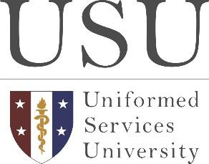
Uniformed Services University
of the Health Sciences
4301 Jones Bridge Road
Bethesda, MD 20814-4799

Jonathan Woodson, MD, MSS, FACS
President

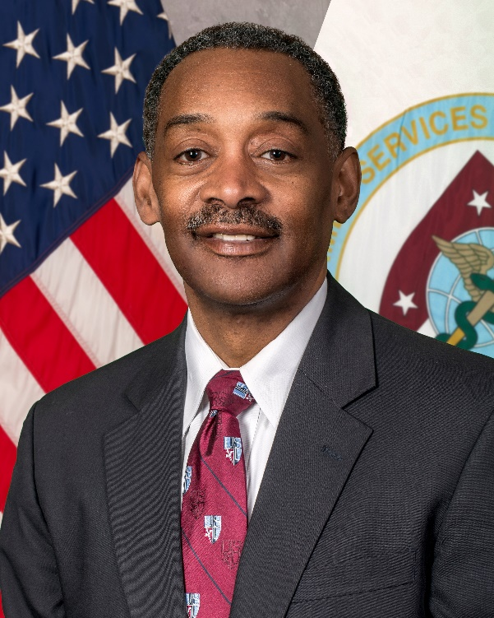
Dr. Jonathan Woodson is the seventh President of the Uniformed Services University of the Health Sciences. As such, he is responsible for the academic, research and leadership mission of the university, which includes more than 2,500 students in the F. Edward Hebert School of Medicine and its associated graduate programs in the biomedical sciences and public health, the Daniel K. Inouye Graduate School of Nursing, and the university’s Postgraduate Dental College and College of Allied Health Sciences. The University has more than 11,500 alumni, many of whom serve the nation as uniformed health providers or civilian scientists. Dr. Woodson also oversees more than 15 research centers and the Armed Forces Radiobiology Research Institute (AFRRI).

Prior to his current position, Dr. Woodson was a Lars Anderson Professor in Management and Professor of the Practice at Boston University’s Questrom School of Business. He holds joint appointments as professor of Surgery at the School of Medicine and professor of Health Law, Policy and Management at the School of Public Health. He established and led the BU university-wide Institute for Health System Innovation and Policy.

From 2010-2016, Dr. Woodson was Assistant Secretary of Defense for Health Affairs and Director of the Tricare Management Activity in the United States Department of Defense (DoD). He was the principal advisor to the Secretary of Defense for all health and force health protection-related issues and ensured the effective execution of the DoD medical mission. He exercised authority, direction and control over the Defense Health Agency, USU, AFRRI, Defense Center of Excellence for Psychological Health and Traumatic Brain Injury, and the Tricare Health Plan serving 9.5 million beneficiaries. In 2016, he was appointed as a member of the USU Board of Regents and later served as its chair.

Dr. Woodson retired at the rank of Major General, United States Army Reserve, and as Commander of the United States Army Reserve Medical Command, Pinellas Park, Florida in June 2022 after 36 years of service. His military deployments include Saudi Arabia for Operation Desert Storm, Kosovo, and Operation Enduring Freedom and Operation Iraqi Freedom. He is a former senior medical officer with the National Disaster Management System, where he responded to the September 11 attack on the World Trade Center.

Before his appointment to the DoD by President Obama in 2010, he was a professor of Surgery and associate dean for Students, Diversity, and Multicultural Affairs and senior attending vascular surgeon at Boston Medical Center.

Dr. Woodson is a graduate of the City College of New York and the New York University School of Medicine. He received his postgraduate medical education at Massachusetts General Hospital, Harvard Medical School, and completed residency training in internal medicine, as well as general and vascular surgery. He is board-certified in internal medicine, general surgery, vascular surgery, and critical care surgery. He also holds a master’s degree in strategic studies (concentration in strategic leadership) from the United States Army War College. In 1992, he was awarded a research fellowship at the Association of American Medical Colleges Health Services Research Institute.

