Biography
CAROL A. ROMANO, PHD, RN, BC, NEA, FACMI, FAAN

PROFESSOR And DEAN of The DANIEL K. INOUYE, GRADUATE SCHOOL OF NURSING
Dr. Carol A. Romano, Rear Admiral, USPHS (Ret) is Professor and Dean of the Daniel K. Inouye Graduate School of Nursing at the Uniformed Services University of the Health Sciences (USU) in Bethesda, Maryland. She directs the organization, operations and strategic planning of the School and serves on the University executive cabinet. She directed implementation of curriculum reform for a new Doctor of Nursing Practice Degree Program for advanced practice nursing, led multiple successful accreditation reviews, achieved Center of Excellence recognition and national ranking in the top 5% for graduate nursing schools.
She received a diploma in nursing (1971) from the Geisinger
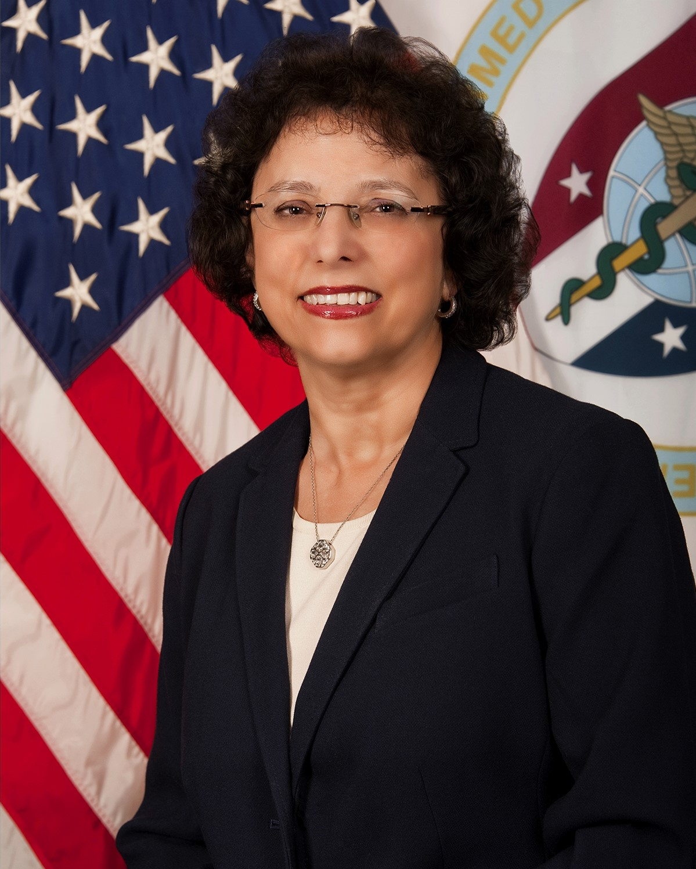
Medical Center School of Nursing in Pennsylvania and earned her Bachelor of Science (1977), Master of Science (1985) and PhD (1993) degrees in nursing from the University of Maryland School of Nursing. She also completed the Interagency Institute for Federal Executives at George Washington University (1993), the Harvard University Senior Managers in Government Program at the Kennedy School of Government (1997), and the University of Pennsylvania Wharton Nurse Executive Leadership Program (2015). She is board certified in nursing informatics and as an advanced nurse executive. Dr. Romano is a fellow in the American Academy of Nursing and the American College of Medical Informatics.
She has served in a variety of leadership positions in the United States Public Health Service (USPHS) in the Office of the Surgeon General (OSG) where she was responsible for oversight and operations that affected 6800 commissioned officers, 4000 reserve officers and 3000 nurses. Her roles involved strategic planning, policy development and advising senior government officials and included Acting Deputy Surgeon General, Acting Chief of Staff OSG, Director of the Office of Reserve Affairs and Chief Nurse Officer, USPHS. She has played a leadership role in emergency response and worked to create the federal health volunteer web site and hot line several days after Hurricane Katrina landed.
Dr. Romano also worked for 34 years at the National Institutes of Health, Clinical Research Center where she served as associate investigator, clinical research nurse, educator, director of nursing communications and recruitment, nursing system specialist, director of clinical informatics and quality assessment, deputy chief information officer and senior advisor for clinical research informatics.
She is recognized as a pioneer in nursing informatics and she helped design and implement one of the first computerized medical information systems in 1976, which provided electronic medical orders and clinical documentation for physicians and nurses in ambulatory and hospital environments.
She was co-architect of the world’s first graduate curriculum in nursing informatics at the University of Maryland School of Nursing. In addition, Dr. Romano served as advisor to the World Health Organization on the management of manpower and health information in developing countries.
She has authored over 50 professional published papers, given numerous presentations at national and international conferences, and has held several university faculty appointments.
She served as editorial board member for referred journals, and co-developer of the National Institutes of Health Nurse Scientist Training Program. Her research includes published studies in the area of informatics education, confidentiality of health records, satisfaction and efficiencies of electronic health records and the adoption of innovations.

RADM Romano’s numerous awards include the AMSUS Federal Health Professionals Lifetime Achievement Award, USU Outstanding Service Medal, Order of Military Medical Merit Medallion, NIH Director’s Award, Assistant Secretary for Health Award, the Surgeon General’s Medallion and Exemplary Service Award, the PHS Meritorious, Outstanding Service, Commendation, Achievement, and Crisis Response medals and several citations. She has been named to the World’s Who’s Who of Women and Who’s Who in American Nursing and recipient of the University of Maryland Illustrious Alumni and Visionary Pioneer awards.

