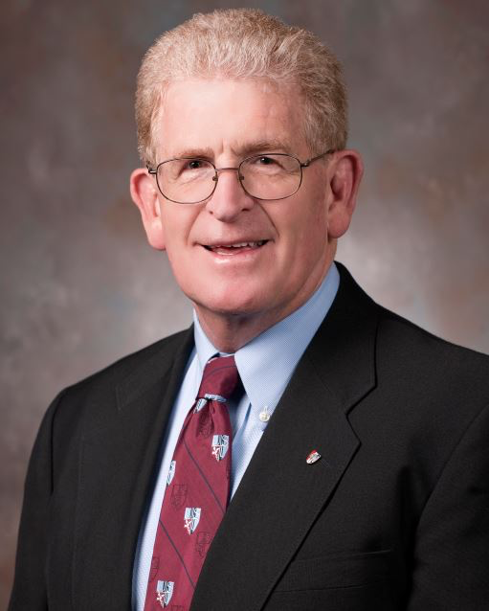
Eric B. Schoomaker, MD, PhD, FACP
Lieutenant General, U.S. Army (Retired)
42nd U.S. Army Surgeon General and
Former Commanding General of the U.S. Army Medical Command
Prior to his retirement in 2012 after 32 years of active service, Lieutenant General (Retired) Eric B. Schoomaker, MD, PhD served as the 42nd U.S. Army Surgeon General and Commanding General of the U.S. Army Medical Command.
He is currently an Emeritus Professor in the Department of Military & Emergency Medicine at the nation’s only Federal health university, the Uniformed Services University of the Health Sciences (USU) in Bethesda, MD. He serves as a Senior Physician Consultant for the Department of Veterans Affairs in the implementation of Veterans Whole Health. His principal interests are two-fold: Complementary and Integrative Health & Medicine (CIH/M) in the shift from a disease management-focused healthcare system to one more centered on the improvement and sustainment of health & well-being; and leadership education. He advocates for the incorporation of CIH/M education and training—emphasizing mindfulness—into the education of health & healthcare professionals. Doctor Schoomaker also promotes the central importance of leadership education and training for health professionals. These interests are reflected in his volunteer work in assisting his local healthcare system in advancing high quality community and hospital-based care and in work on healthcare futures.
He committed his career to meeting the health needs of soldiers, their families, and veterans through initiatives that Army Medicine implemented throughout its facilities in the U.S., Europe, and the Pacific, focusing on soldier medical readiness, enhancing battlefield care, establishing a comprehensive behavioral health system of care, fostering a culture of trust, advancing comprehensive pain management, and promoting health by preventing combat wounds, injury, and illness.
Doctor Schoomaker is an internal medicine physician and hematologist with a PhD in Human Genetics. He held many assignments including Chief of the Army Medical Corps (physicians), oversight of all Army medical education, command of two Army regional medical commands as well as the Eisenhower Army Medical Center in Fort Gordon, GA, the Walter Reed Army Medical Center in Washington, DC, the Army’s Medical Research & Materiel Command and Fort Detrick, MD, a community hospital, and a deployable medical brigade serving Europe, the Mideast and Africa.
He is the recipient of numerous military awards, including those from France and Germany, the 2012 Dr. Nathan Davis Award from the American Medical Association for outstanding government service, an Honorary Doctor of Science from Wake Forest University, a Doctor of Letters in Medicine from the Baylor College of Medicine, and the Philipp M. Lippe Award from the American Academy of Pain Medicine for outstanding contributions to the social and political aspect of Pain Medicine.
Doctor Schoomaker is married to Audrey, a former Army Nurse Corps Officer and a therapeutic yoga and mindfulness instructor, and a wellness coach; they are grateful parents of a son who is an aspiring jazz musician/song-writer and two married daughters—an elementary school counselor and a medical student.

