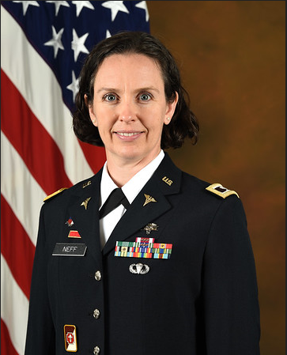
COL Laurel Neff, US Army, Medical Corps

Colonel Laurel Neff recently completed a year as the NDU Command Surgeon, where she focused on the readiness and wellness of all staff and students across 6 colleges and 3 locations, and as of August 2021, she is now a student at the Dwight D. Eisenhower School for National Security and Resource Strategy. COL Neff was born in Philadelphia, PA and is a graduate of the United States Military Academy and the U.S. Army Command and General Staff College. In addition to her Doctorate of Osteopathic Medicine from the Philadelphia College of Osteopathic Medicine, she also holds a Masters of Business Administration from Pacific Lutheran University.
COL Neff entered the Army as a Medical Corps Officers in 1997. She is board certified by the American Board of Family Medicine, and is a Fellow of the American Academy of Family Physicians.
In addition to her recent role as Command Surgeon, COL Neff has served in a variety of teaching and leadership positions including: Residency Faculty and Student Coordinator at Tripler Army Medical Center; Officer in Charge at the Military Medical Clinic, Baghdad, Iraq; Brigade Surgeon, 82nd Sustainment Brigade, Fort Bragg, NC; Deputy Commander for Clinical Services, Bassett Army Community Hospital, AK; Family Medicine Department Chief, Madigan Army Medical Center, WA; Deputy Commander for Health Readiness, Madigan Army Medical Center, WA; and, Deputy Corps Chief for the Medical Corps, at the Office of the Surgeon General.
COL Neff’s awards and decorations include Meritorious Service Medal with 4 Oak Leaf Clusters, Army Commendation Medal, Army Achievement Medal with 4 Oak Leaf Clusters, Global War on Terrorism and Korea Service Medals, along with the Parachutist and Expert Field Medical Badges. She is a member of the Order of Military Medical Merit. She is married with two children and lives in Fairfax Station, VA.

