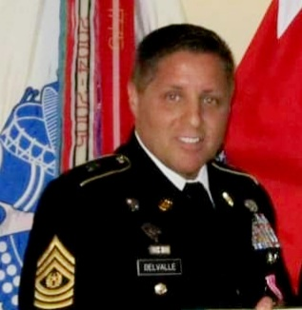
Command Sergeant Major (Retired)
Rodolfo Ricardo DelValle

CSM (Ret) DelValle began his career in the U. S. Army in September 1988. He attended airborne school in Ft. Benning Ga, along with the Ranger Indoctrination Program (RIP). Upon completion from RIP, he was assigned to 1st Battalion 75th Ranger Regiment, Hunter Army Airfield, Savannah Georgia.

CSM (Ret) DelValle’s leadership assignments include: Weapons Platoon medic, B Co 1/75 Ranger BN, Hunter Army Airfield, Savannah Ga. CSM (Ret) DelValle served as the Senior Medic, HQ Co, 1/75 Ranger BN, Savannah Ga, where he deployed to several places in the capacity of the Battalion Senior Medic for 1/75 Ranger BN. CSM(Ret) DelValle also served as the NCOIC Family Practice, Madigan Army Medical Center, Ft. Lewis WA; NCOIC Emergency Room, Madigan Army Medical Center, Ft. Lewis WA; Operations Sergeant, Readiness Operation Cell (ROC), Madigan Army Medical Center, Ft. Lewis WA; Detachment Sergeant Kitzingen Health Clinic, Kitzingen Germany; First Sergeant, 67th Combat Support Hospital, Wurzburg Germany; First Sergeant, 67th Combat Support Hospital Forward, Task Force Medical Falcon, Kosovo 6A; Senior Enlisted Advisor, Defense Medical Readiness Training Institute, Ft. Sam Houston TX.

As Command Sergeant Major, he served as the Command Sergeant Major of the 16th MEDLOG BN, Camp Carroll Korea; Medical Center Brigade CSM, Walter Reed Medical Center Brigade, and Command Sergeant Major Walter Reed Health Care System; Command Sergeant Major for the US Army Element, Walter Reed National Military Medical Center.

During his tenure, he deployed in many operations to include Desert Storm, Desert Shield, Haiti, Panama Invasion, and was able to deploy with a Special Forces group for three months in support of Counter Drug interdiction operations.

CSM (Ret) DelValle’s awards include the Legion of Merit (LOM), Meritorious Service Medal with 5OLC (Oak Leaf Clusters), the Army Commendation Medal with 4OLC, the Joint Service Achievement Medal, the Army Achievement Medal with 3OLC, Good Conduct Medal 8th award, the Expeditionary Medal with Arrow Head and bronze star, Southwest Asia Medal with two bronze stars, Kosovo Campaign Medal with bronze star, Humanitarian Service Medal, the Combat Medical Badge, Expert Field Medical Badge, Airborne Badge with combat jump, HALO badge (Military Freefall), the Ranger Tab, German Schutzenschnur (silver) badge and numerous others.

CSM (Ret) DelValle is a member of the Order of Military Medical Merit (O2M3) and the Distinguished Member of the Army Medical Department Regiment. CSM(Ret) DelValle’s military and Civilian Education Includes: MBA, the University of Phoenix, BS Degree, Excelsior College, all Enlisted Leadership Courses and graduated from the United States Army Sergeant Major Academy (USASMA) Class 55.

CSM (Ret) DelValle retired October 1, 2012 after 26 years of service. He is married to Tanya Enriquez DelValle.

