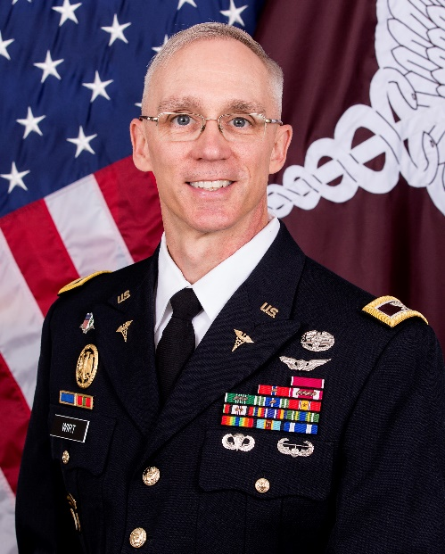
COLONEL MICHAEL WIRT, MD, PhD
Acting Commander, Brooke Army Medical Center, San Antonio, Texas

Colonel (COL) Michael D. Wirt was commissioned as a Second Lieutenant in the Chemical Corps in 1986, after graduating from U.S. Army Officer Candidate School in Fort Benning, Georgia. Following graduation, he served on active duty with the 1-70th Armor Battalion, 5th Infantry Division, and in multiple subsequent assignments as a Chemical Officer in the Army Reserve until 1994. During this period, COL Wirt completed a Master’s Degree and Doctorate in Bioinorganic Chemistry at Georgetown University, followed by a Post-Doctoral Fellowship in magnetic resonance at Albert Einstein College of Medicine. COL Wirt is also a 1998 graduate of Albert Einstein College of Medicine, where he obtained his Doctorate of Medicine degree, followed by completion of an internship in General Surgery and his residency in Diagnostic Radiology at Tripler Army Medical Center, Honolulu, Hawaii, in 2004.

COL Wirt completed Fellowship training in Neuroradiology at the University of California San Francisco from 2004-2006 and was subsequently assigned as the Chief of Radiology at William Beaumont Army Medical Center from 2006-2009. In 2009, COL Wirt was selected to serve as the Brigade Surgeon for the 502nd Infantry Regiment, 101st Airborne Division (Air Assault). He deployed to Kandahar Province, Afghanistan, in 2010 as the Combined Task Force Strike Surgeon, Regional Command South, International Security Assistance Force, where the Task Force earned the Presidential Unit Citation. Upon redeployment in 2011, he was assigned as the Deputy Commander for Clinical Services at Blanchfield Army Community Hospital, Fort Campbell, Kentucky, home to the 101st Airborne Division (Air Assault). COL Wirt deployed again in 2013 as the Officer-in-Charge of the United States Contingent at the United Kingdom’s Bastion Role 3 Hospital in Helmand Province, Afghanistan before assuming command of the U.S. Army Institute of Surgical Research in San Antonio, Texas from July 2014 to July 2016. COL Wirt served as the Eighth Army Command Surgeon in the Republic of Korea from August 2016 to August 2018 and as the Deputy Commanding Officer Brooke Army Medical Center from August 2018 to April 2021.

COL Wirt is Board Certified in both Diagnostic and Neuroradiology and has served as the Radiology Consultant to the Army Surgeon General from 2012-2016. He holds an appointment as an Assistant Professor of Radiology at the Uniformed Services University of the Health Sciences and is a Senior Member of the American Society of Neuroradiology. He is a distinguished graduate of the U.S. Army War College and a graduate of the Army Command and General Staff College, the Army Flight Surgeon course, and the Army Airborne and Air Assault schools. His awards and decorations include the Legion of Merit, the Bronze Star Medal (1 OLC), the Meritorious Service Medal (5 OLCs), the Army Commendation Medal (3 OLCs), and the Army Achievement Medal (1 OLC). He is a recipient of the Combat Medical Badge, Flight Surgeon Badge, Parachutist Badge and the Air Assault Badge. He holds the Army Surgeon General’s “A” Proficiency Designator, the German Armed Forces Badge for Military Proficiency (Gold), and is a member of the Order of Military Medical Merit.

